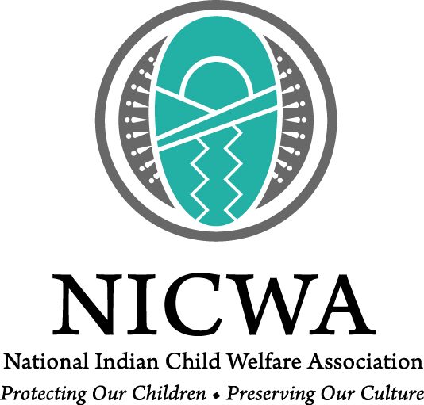
As a result of attending this training, participants will:
- Understand the historic relationship between Indian children and the United States child welfare policy which led to ICWA
- Learn the skills needed to identify, train and guide a potential Qualified Expert Witness (QEW) through their court process
- Be prepared with the skills necessary to lead a QEW through the court process.
- Recognize the elements and skills in leading a QEW through court procedure process.

