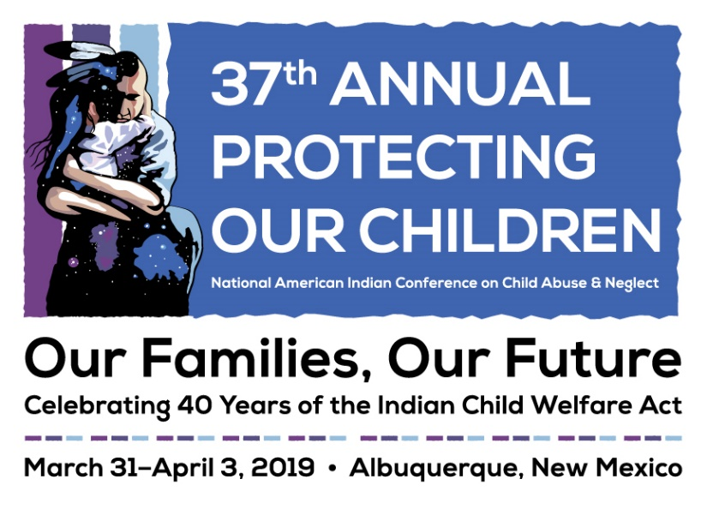

Letter to Supervisor
Date

Dear <supervisor's name>,

I would like to represent our <tribe/organization> at NICWA’s 37th Annual Protecting our Children National American Indian Conference on Child Abuse and Neglect in Albuquerque, New Mexico, on March 31–April 3, hosted by the National Indian Child Welfare Association. Attending this conference will enable me to further my professional development at the nation’s leading Indian Child Welfare conference.

The four-day conference, gathering over 1,200 professionals, will feature an impressive program that will facilitate dialogue between tribes, federal partners, nonprofits, and legal professionals, with sessions on children’s mental health, child welfare, foster care, adoption services, judicial and legal affairs, and youth and family involvement. Having the opportunity to network with other professionals nationwide will help me to use the most updated and relevant information and policies available in Indian child welfare to dictate my work. I am confident that the presentations and discussions will increase my productivity in <name of your tribe/organization>.

The conference provides a unique opportunity for tribes, federal partners, and professionals to share their information, stories, experiences, collaborate, and strategize in one space. In addition, by attending this conference I will have the opportunity to obtain over 15 CEUs by the NASW or over 8 CLEs to contribute to my professional development.

I am seeking support for the travel expenses to the conference. A detailed cost breakdown is included below:

Registration Fee: <ranging from $300–625 depending on registration type>
Roundtrip Airfare: <$xxxx>
Hotel: <varies depending upon hotel: $118–143 per night per night plus tax>
Meals: <cost varies>

The total cost associated with attending this conference is: <$xxxx>.

The opportunity for me to gain knowledge in leading Indian child welfare research and network with some of the most influential individuals in Indian Country makes my attendance a wise investment to <name of your tribe/organization’s> future.

If you have further questions, you can inquire at http://www.nicwa.org/conference or e-mail training@nicwa.org.

Sincerely,
<Your name here>

