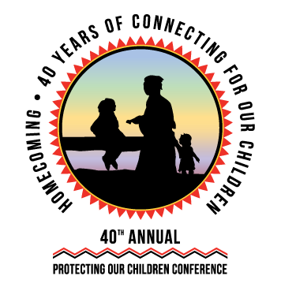

Letter to Supervisor
Date

Dear <supervisor's name>,

I would like to represent our <tribe/organization> at NICWA’s 40th Annual Virtual Protecting our Children Conference on April 3-6, 2022, hosted by the National Indian Child Welfare Association. Attending this conference will enable me to further my professional development at the nation’s leading Indian Child Welfare conference.

The four-day hybrid conference, gathering over 1,400 professionals, will feature an impressive program that will facilitate dialogue between tribes, federal partners, nonprofits, and legal professionals, with sessions on children’s mental health, child welfare, foster care, adoption services, judicial and legal affairs, and youth and family involvement. Having the opportunity to network with other professionals nationwide will help me use the most updated and relevant information and policies available in Indian child welfare to dictate my work. I am confident that the presentations and discussions will increase my productivity in <name of your tribe/organization>.

The conference provides a unique opportunity for tribes, federal partners, and professionals to share their information, stories, experiences, collaborate, and strategize in one virtual space. In addition, by attending this conference I will have the opportunity to obtain CEUs by the NASW–Washington State Chapter or CLEs to contribute to my professional development.

I am seeking support for the registration fees to the conference. Please see below for registration costs. The estimate below does not include travel costs.

Registration Fee: <ranging from $225–700 depending on registration type. Please see www.nicwa.org/cost-registration/ for costs>

The opportunity for me to gain knowledge in leading Indian child welfare research and network with some of the most influential individuals in Indian Country makes my attendance a wise investment for<name of your tribe/organization’s> future.

If you have further questions, you can inquire at www.nicwa.org/conference or e-mail training@nicwa.org.

Sincerely,
<Your name here>

